Window to Viewport Transformation in Computer Graphics with Implementation

Window to Viewport Transformation is the process of transforming 2D world-coordinate objects to device coordinates. Objects inside the world or clipping window are mapped to the viewport which is the area on the screen where world coordinates are mapped to be displayed.
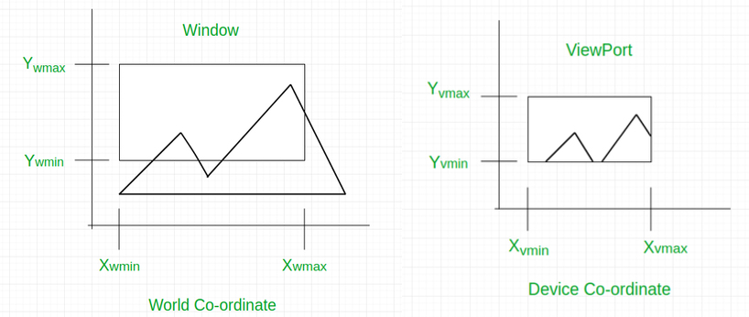
General Terms:
- World coordinate – It is the Cartesian coordinate w.r.t which we define the diagram, like X_{wmin}, X_{wmax}, Y_{wmin}, Y_{wmax}
- Device Coordinate –It is the screen coordinate where the objects are to be displayed, like X_{vmin}, X_{vmax}, Y_{vmin}, Y_{vmax}
- Window –It is the area on the world coordinate selected for display.
- ViewPort –It is the area on the device coordinate where graphics is to be displayed.
Mathematical Calculation of Window to Viewport:
It may be possible that the size of the Viewport is much smaller or greater than the Window. In these cases, we have to increase or decrease the size of the Window according to the Viewport and for this, we need some mathematical calculations.
(x_{w}, y_{w}): A point on Window
(x_{v}, y_{v}): Corresponding point on Viewport
We have to calculate the point (x_{v}, y_{v})
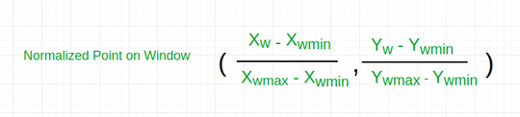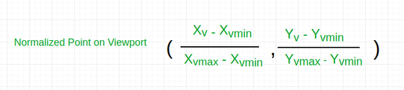
Now the relative position of the object in Window and Viewport are same.
For x coordinate,
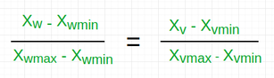
For y coordinate,
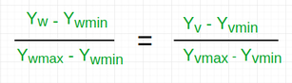
So, after calculating for x and y coordinate, we get
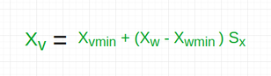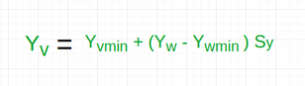
Where s_{x} is the scaling factor of x coordinate and s_{y} is the scaling factor of y coordinate
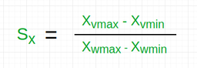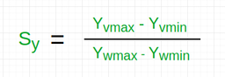
Example: Let us assume,
- for window, X_{wmin} = 20, X_{wmax} = 80, Y_{wmin} = 40, Y_{wmax} = 80.
- for viewport, X_{vmin} = 30, X_{vmax} = 60, Y_{vmin} = 40, Y_{vmax} = 60.
- Now a point ( X_{w}, Y_{w} ) be ( 30, 80 ) on the window. We have to calculate that point on the viewport
i.e ( X_{v}, Y_{v} ).
- First of all, calculate the scaling factor of x coordinate S_{x} and the scaling factor of y coordinate S_{y} using the above-mentioned formula.
S_{x} = ( 60 - 30 ) / ( 80 - 20 ) = 30 / 60
S_{y} = ( 60 - 40 ) / ( 80 - 40 ) = 20 / 40
- So, now calculate the point on the viewport ( X_{v}, Y_{v} ).
X_{v} = 30 + ( 30 - 20 ) * ( 30 / 60 ) = 35
Y_{v} = 40 + ( 80 - 40 ) * ( 20 / 40 ) = 60
- So, the point on window ( X_{w}, Y_{w} ) = ( 30, 80 ) will be ( X_{v}, Y_{v} ) = ( 35, 60 ) on viewport.
Here is the implementation of the above approach:
- C++
- C
- Java
- Python3
- C#
- Javascript
// C++ program to implement
// Window to ViewPort Transformation

#include <iostream>
using namespace std;

// Function for window to viewport transformation
void WindowtoViewport(int x_w, int y_w, int x_wmax,
int y_wmax, int x_wmin, int y_wmin,
int x_vmax, int y_vmax, int x_vmin,
int y_vmin)
{
// point on viewport
int x_v, y_v;

// scaling factors for x coordinate and y coordinate
float sx, sy;

// calculating Sx and Sy
sx = (float)(x_vmax - x_vmin) / (x_wmax - x_wmin);
sy = (float)(y_vmax - y_vmin) / (y_wmax - y_wmin);

// calculating the point on viewport
x_v = x_vmin + (float)((x_w - x_wmin) * sx);
y_v = y_vmin + (float)((y_w - y_wmin) * sy);

cout<< "The point on viewport: ("<<x_v <<","<< y_v<<")" ;
}

// Driver Code
int main()
{
// boundary values for window
int x_wmax = 80, y_wmax = 80, x_wmin = 20, y_wmin = 40;

// boundary values for viewport
int x_vmax = 60, y_vmax = 60, x_vmin = 30, y_vmin = 40;

// point on window
int x_w = 30, y_w = 80;

WindowtoViewport(30, 80, 80, 80, 20, 40, 60, 60, 30, 40);
}

// This code is contributed by khusboogoyal499.
Output:
The point on viewport: (35, 60 )

Time Complexity: O(1), as we are not using any looping statements.
Space Complexity: O(1) , as we are not using any extra space.

Line Clipping:
It is performed by using the line clipping algorithm. The line clipping algorithms are:
- Cohen Sutherland Line Clipping Algorithm
- Midpoint Subdivision Line Clipping Algorithm
- Liang-Barsky Line Clipping Algorithm

Cohen Sutherland Line Clipping Algorithm:
In the algorithm, first of all, it is detected whether line lies inside the screen or it is outside the screen. All lines come under any one of the following categories:
- Visible
- Not Visible
- Clipping Case
1. Visible: If a line lies within the window, i.e., both endpoints of the line lies within the window. A line is visible and will be displayed as it is.
2. Not Visible: If a line lies outside the window it will be invisible and rejected. Such lines will not display. If any one of the following inequalities is satisfied, then the line is considered invisible. Let A (x₁,y₂) and B (x₂,y₂) are endpoints of line.
x_{min},x_{max} are coordinates of the window.
y_{min},y_{max} are also coordinates of the window.
x₁>x_{max}
x₂>x_{max}
y₁>y_{max}
y₂>y_{max}
x₁<x_{min}
x₂<x_{min}
y₁<y_{min}
y₂<y_{min}
3. Clipping Case: If the line is neither visible case nor invisible case. It is considered to be clipped case. First of all, the category of a line is found based on nine regions given below. All nine regions are assigned codes. Each code is of 4 bits. If both endpoints of the line have end bits zero, then the line is considered to be visible.
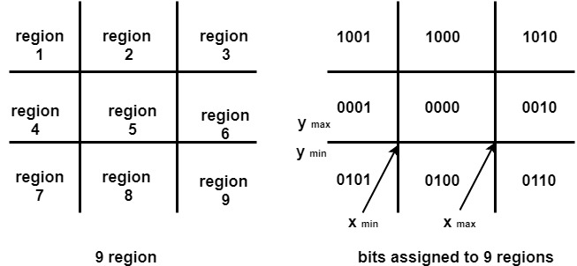
The center area is having the code, 0000, i.e., region 5 is considered a rectangle window.
Following figure show lines of various types
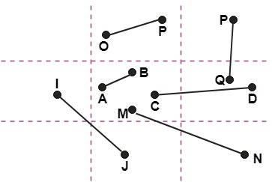
Line AB is the visible case
Line OP is an invisible case
Line PQ is an invisible line
Line IJ are clipping candidates
Line MN are clipping candidate
Line CD are clipping candidate

Advantage of Cohen Sutherland Line Clipping:
- It calculates end-points very quickly and rejects and accepts lines quickly.
- It can clip pictures much large than screen size.

Algorithm of Cohen Sutherland Line Clipping:
Step1:Calculate positions of both endpoints of the line
Step2:Perform OR operation on both of these end-points
Step3:If the OR operation gives 0000
Then
line is considered to be visible
else
Perform AND operation on both endpoints
If And ≠ 0000
then the line is invisible
else
And=0000
Line is considered the clipped case.
Step4:If a line is clipped case, find an intersection with boundaries of the window
m=(y₂-y₁ )(x₂-x₁)
(a) If bit 1 is "1" line intersects with left boundary of rectangle window
y₃=y₁+m(x-X₁)
where X = X_{wmin}
where X_{wmin}is the minimum value of X co-ordinate of window
(b) If bit 2 is "1" line intersect with right boundary
y₃=y₁+m(X-X₁)
where X = X_{wmax}
where X more is maximum value of X co-ordinate of the window
(c) If bit 3 is "1" line intersects with bottom boundary
X₃=X₁+(y-y₁)/m
where y = y_{wmin}
y_{wmin} is the minimum value of Y co-ordinate of the window
(d) If bit 4 is "1" line intersects with the top boundary
X_{3=X}1+(y-y₁)/m
where y = y_{wmax}
y_{wmax} is the maximum value of Y co-ordinate of the window

Example of Cohen-Sutherland Line Clipping Algorithm:
Let R be the rectangular window whose lower left-hand corner is at L (-3, 1) and upper right-hand corner is at R (2, 6). Find the region codes for the endpoints in fig:
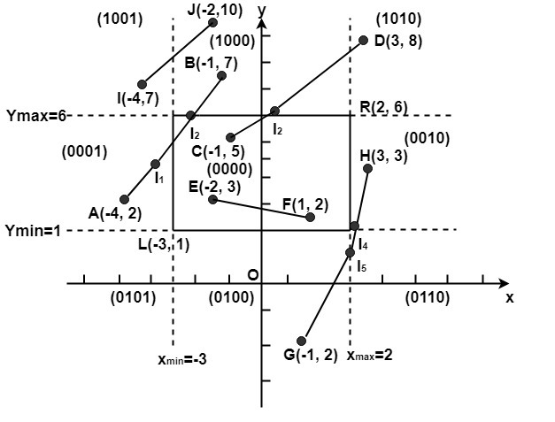
The region code for point (x, y) is set according to the scheme
Bit 1 = sign (y-y_{max})=sign (y-6) Bit 3 = sign (x-x_{max})= sign (x-2)
Bit 2 = sign (y_{min}-y)=sign(1-y) Bit 4 = sign (x_{min}-x)=sign(-3-x)
Here
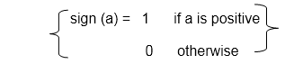
So
A (-4, 2)→ 0001 F (1, 2)→ 0000
B (-1, 7) → 1000 G (1, -2) →0100
C (-1, 5)→ 0000 H (3, 3) → 0100
D (3, 8) → 1010 I (-4, 7) → 1001
E (-2, 3) → 0000 J (-2, 10) → 1000
We place the line segments in their appropriate categories by testing the region codes found in the problem.
Category1 (visible): EF since the region code for both endpoints is 0000.
Category2 (not visible): IJ since (1001) AND (1000) =1000 (which is not 0000).
Category 3 (candidate for clipping): AB since (0001) AND (1000) = 0000, CD since (0000) AND (1010) =0000, and GH. since (0100) AND (0010) =0000.
The candidates for clipping are AB, CD, and GH.
In clipping AB, the code for A is 0001. To push the 1 to 0, we clip against the boundary line x_{min}=-3. The resulting intersection point is I₁ (-3,3). We clip (do not display) AI₁ and I₁ B. The code for I₁is 1001. The clipping category for I₁ B is 3 since (0000) AND (1000) is (0000). Now B is outside the window (i.e., its code is 1000), so we push the 1 to a 0 by clipping against the line y_{max}=6. The resulting intersection is l₂ (-1,6). Thus I₂ B is clipped. The code for I₂ is 0000. The remaining segment I₁ I₂ is displayed since both endpoints lie in the window (i.e., their codes are 0000).
For clipping CD, we start with D since it is outside the window. Its code is 1010. We push the first 1 to a 0 by clipping against the line y_{max}=6. The resulting intersection I₃ is (,6),and its code is 0000. Thus I₃ D is clipped and the remaining segment CI₃ has both endpoints coded 0000 and so it is displayed.
For clipping GH, we can start with either G or H since both are outside the window. The code for G is 0100, and we push the 1 to a 0 by clipping against the line y_{min}=1.The resulting intersection point is I₄ (2,1) and its code is 0010. We clip GI₄ and work on I₄ H. Segment I₄ H is not displaying since (0010) AND (0010) =0010.

Program to perform Line Clipping using Cohen Sutherland Algorithm:
- #include <iostream.h>
- #include <conio.h>
- #include <graphics.h>
- #include <dos.h>
- class data
- {
- int gd, gmode, x, y, xmin,ymin,ymax,xmax;
- int a1,a2;
- float x1, y1,x2,y2,x3,y3;
- int xs, ys, xe, ye;
- float maxx,maxy;
- public:
- void getdata ();
- void find ();
- void clip ();
- void display (float, float,float,float);
- void checkonof (int);
- void showbit (int);
- };
- void data :: getdata ()
- {
- cout<<"Enter the minimum and maximum coordinate of window (x, y) ";
- cin >>xmin>>ymin>>xmax>>ymax;
- cout<<"Enter the end points of the line to be clipped";
- cin >>xs>>ys>>xe>>ye;
- display (xs, ys, xe,ye);
- }
- void data :: display (float, xs, float, ys,float xe, float ye)
- {
- int gd=DETECT;
- initgraph (&gd,&gmode, "");
- maxx=getmaxx();
- maxy=getmaxy();
- line (maxx/2,0,maxx/2,maxy);
- line (0, maxy/2,maxx,maxy/2);
- rectangle (maxx/2+xmin,maxy/2-ymax,maxx/2+xmax,maxy/2-ymin);
- line (maxx/2+xs,maxy/2-ys,maxx/2+xe,maxy/2-ye);
- getch();
- }
- void data :: find ()
- {
- a1=0;
- a2=0;
- if ((ys-ymax)>0)
- a1+=8;
- if ((ymin-ys)>0)
- a1+=4;
- if ((xs-xmax)>0)
- a1+=2;
- if ((xmin-xs)>0)
- a1+=1;
- if ((ye-ymax)>0)
- a2+=8;
- if ((ymin-ye)>0)
- a2+=4;
- if ((xe-xmax)>0)
- a2+=2;
- if ((xmin-xe)>0)
- a2+=1;
- cout<<"\nThe area code of Ist point is ";
- showbit (a1);
- getch ();
- cout <<"\nThe area code of 2nd point is ";
- showbit (a2);
- getch ();
- }
- void data :: showbit (int n)
- {
- int i,k, and;
- for (i=3;i>=0;i--)
- {
- and =1<<i;
- k = n?
- k ==0?cout<<"0": cout<<"1\"";
- }
- }
- void data ::clip()
- {
- int j=a1&a2;
- if (j==0)
- {
- cout<<"\nLine is perfect candidate for clipping";
- if (a1==0)
- {
- else
- {
- checkonof(a1);
- x2=x1;y2=y1;
- }
- if (a2=0)
- {
- x3=xe; y3=ye;
- }
- else
- {
- checkonof (a2);
- x3=x1; y3=y1;
- }
- xs=x2; ys=y2;xe=x3;ye=y3;
- cout << endl;
- display (xs,ys,xe,ye);
- cout<<"Line after clipping";
- getch ()
- }
- else if ((a1==0) && (a2=0))
- {
- cout <<"\n Line is in the visible region";
- getch ();
- }
- }
- void data :: checkonof (int i)
- {
- int j, k,l,m;
- 1=i&1;
- x1=0;y1=0;
- if (1==1)
- {
- x1=xmin;
- y1=ys+ ((x1-xs)/ (xe-xs))*(ye-ys);
- }
- j=i&8;
- if (j>0)
- {
- y1=ymax;
- x1=xs+(y1-ys)/(ye-ys))*(xe-xs);
- }
- k=i & 4;
- if (k==1)
- {
- y1=ymin;
- x1=xs+((y1-ys)/(ye-ys))*(xe-xs);
- }
- m= i&2;
- if (m==1)
- {
- x1=xmax;
- y1=ys+ ((x1-xs)/ (xe-xs))*(ye-ys);
- }
- main ()
- {
- data s;
- clrscr();
- s.getdata();
- s.find();
- getch();
- closegraph ();
- return ();
- }
Output:
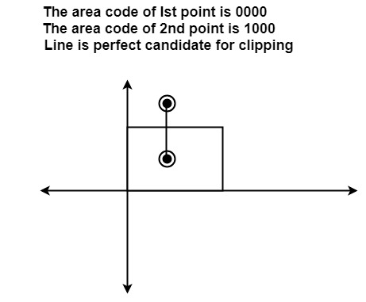

Mid Point Subdivision Line Clipping Algorithm:
It is used for clipping line. The line is divided in two parts. Mid points of line is obtained by dividing it in two short segments. Again division is done, by finding midpoint. This process is continued until line of visible and invisible category is obtained. Let (x_{i},y_{i}) are midpoint
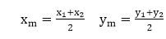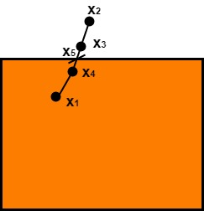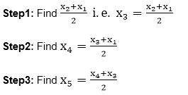
x₅lie on point of intersection of boundary of window.

Advantage of midpoint subdivision Line Clipping:
It is suitable for machines in which multiplication and division operation is not possible. Because it can be performed by introducing clipping divides in hardware.

Algorithm of midpoint subdivision Line Clipping:
Step1: Calculate the position of both endpoints of the line
Step2: Perform OR operation on both of these endpoints
Step3: If the OR operation gives 0000
then
Line is guaranteed to be visible
else
Perform AND operation on both endpoints.
If AND ≠ 0000
then the line is invisible
else
AND=6000
then the line is clipped case.
Step4: For the line to be clipped. Find midpoint
X_{m}=(x₁+x₂)/2
Y_{m}=(y₁+y₂)/2
X_{m}is midpoint of X coordinate.
Y_{m}is midpoint of Y coordinate.
Step5: Check each midpoint, whether it nearest to the boundary of a window or not.
Step6: If the line is totally visible or totally rejected not found then repeat step 1 to 5.
Step7: Stop algorithm.
Example: Window size is (-3, 1) to (2, 6). A line AB is given having co-ordinates of A (-4, 2) and B (-1, 7). Does this line visible. Find the visible portion of the line using midpoint subdivision?
Solution:
Step1: Fix point A (-4, 2)
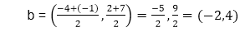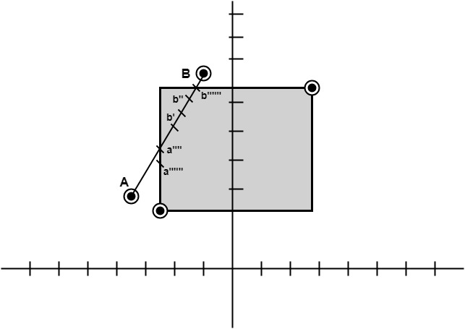
Step2: Find b"=mid of b'and b
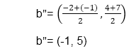
So (-1, 5) is better than (2, 4)
Find b"&bb"(-1, 5) b (-1, 7)
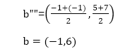
So B""to B length of line will be clipped from upper side
Now considered left-hand side portion.
A and B""are now endpoints
Find mid of A and B""
A (-4, 2) B ""(-1, 6)

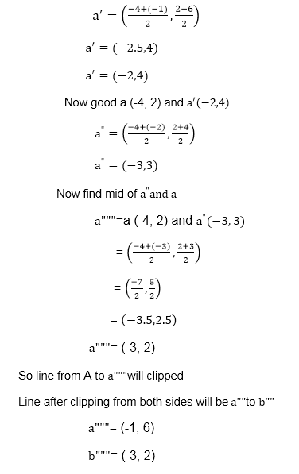 Sutherland-Hodgeman Polygon Clipping:
It is performed by processing the boundary of polygon against each window corner or edge. First of all entire polygon is clipped against one edge, then resulting polygon is considered, then the polygon is considered against the second edge, so on for all four edges.
Four possible situations while processing
- If the first vertex is an outside the window, the second vertex is inside the window. Then second vertex is added to the output list. The point of intersection of window boundary and polygon side (edge) is also added to the output line.
- If both vertexes are inside window boundary. Then only second vertex is added to the output list.
- If the first vertex is inside the window and second is an outside window. The edge which intersects with window is added to output list.
- If both vertices are the outside window, then nothing is added to output list.
Following figures shows original polygon and clipping of polygon against four windows.
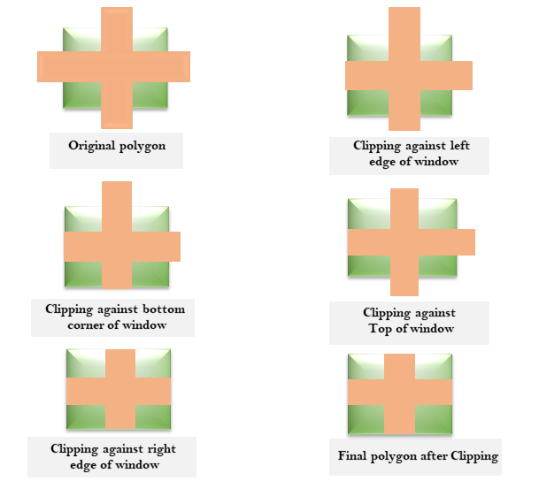

Disadvantage of Cohen Hodgmen Algorithm:
This method requires a considerable amount of memory. The first of all polygons are stored in original form. Then clipping against left edge done and output is stored. Then clipping against right edge done, then top edge. Finally, the bottom edge is clipped. Results of all these operations are stored in memory. So wastage of memory for storing intermediate polygons.
